Radisson Blu Prices
The special prices that Radisson Blu offers to the seminar guests are
International Aikido meeting 28.03-2.04.2023 Athens
 | Price/ room/ stay
Single room | € 135,00 ΒΒ with breakfast
Double room | € 155,00 ΒΒ with breakfast
Triple room | € 185,00 ΒΒ with breakfast
the above mentioned prices are per room per day and include a rich breakfast. Also there is a Wifi in the room, including a gym space usage. The prices do NOT include the state tax of 4€ per day. A different receipt is issued for that.
Check location in google maps here https://goo.gl/maps/Him1Bu7HsPWRR5oeA
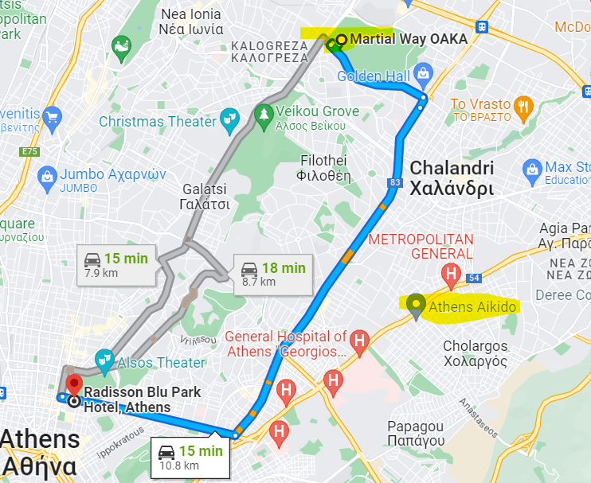

Titania Hotel Prices
The special prices that Titania Hotel offers to the seminar guests are
International Aikido meeting 28.03-4.04.2023 Athens
 | Price/ room/ stay
Single room | € 120,00 ΒΒ with breakfast
Double room | € 145,00 ΒΒ with breakfast
Triple room | € 175,00 ΒΒ with breakfast
the above mentioned prices are per room per day and include a rich breakfast.
The prices do NOT include the state tax of 3€ per day. A different receipt is issued for that.
Check location in google maps here https://goo.gl/maps/goMbtgukNGBP14597
